**Customer Purchasing Behaviour**

**Assessment of Risk**

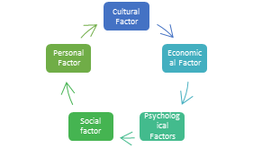

Consumer buying behavior refers to the series of actions that consumers take before making a purchase of any product or service. It involves all the steps, from the first awareness stage to the evaluation and market research before the final step of making a purchase.

Consumer behavior in the market is a crucial aspect of modern business. From making purchasing decisions to influencing others, it is the study of factors that play a role in the choices, actions, and attitudes of buyers. By analyzing this behavior, companies can better understand their customers and make strategic business decisions that lead to increased sales and profits.

Consumer behavior research helps companies identify customers’ needs, preferences, and motivations that drive their purchasing decisions. By gaining insights into why customers buy certain products or services,

Understanding the five major factors influencing consumer buying behavior—psychological, social, cultural, personal, and economic—is essential for businesses aiming to connect with their target audience effectively.

This knowledge is crucial for marketers because it helps them to better communicate with customers. They can fill the market gap and identify the items that are required and the products that are no longer in use by knowing how customers choose a product.





**Importance of Consumer Behaviour**

**Inventory Planning**

**Customer loyalty**

**Reating Customers**

**Differentiation of the Consumer**